**PATENTS PROSECUTION:**

Patent prosecution is a process where applicants and/or their representatives interact with the Patent Office to get a grant for their patent application

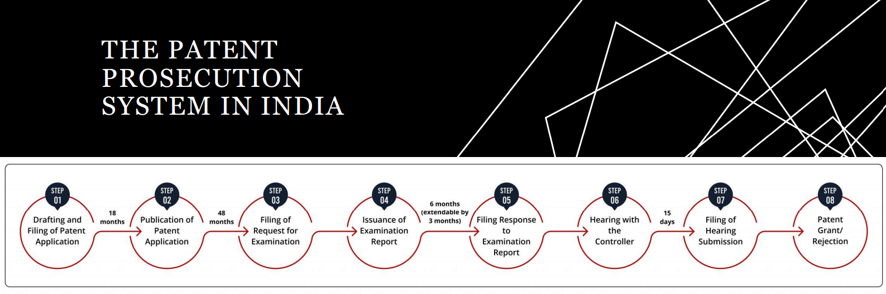

The application is sent for a technical examination to check whether the invention meets the three basic requirements of patentability, i.e., novelty, inventiveness, and industrial applicability.

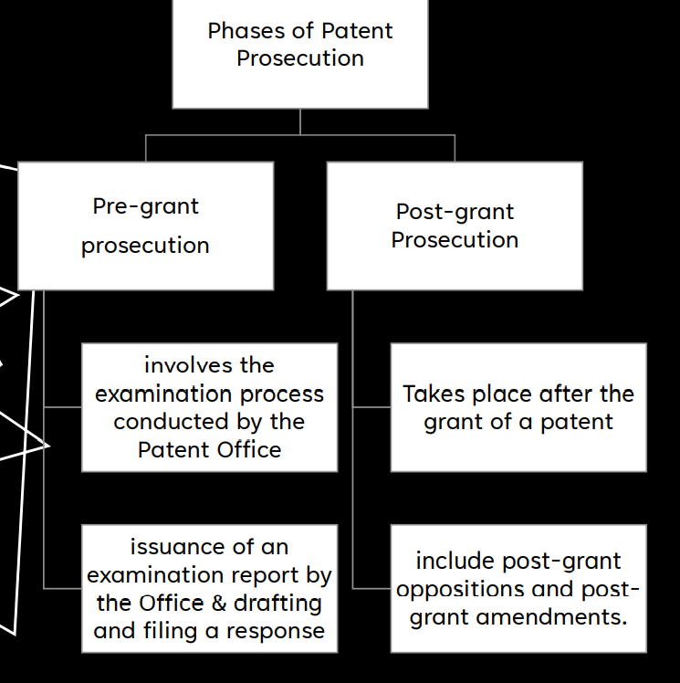

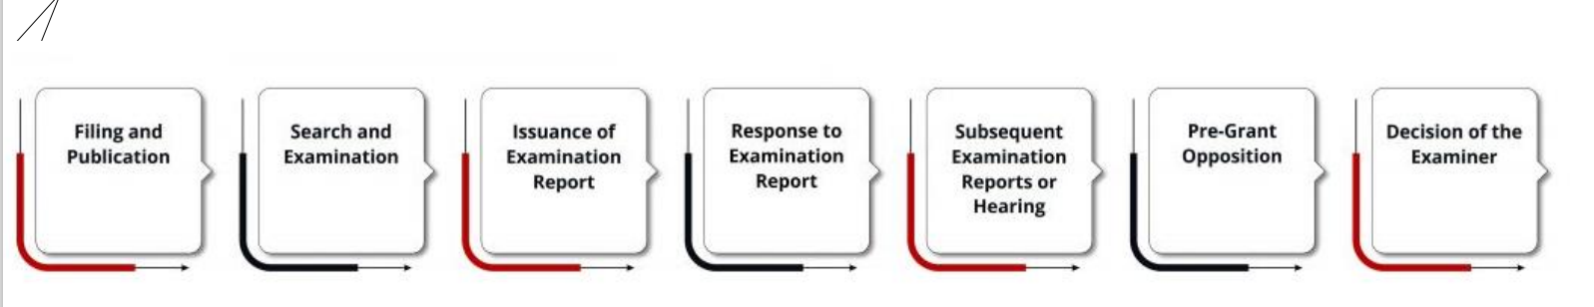

1. **Filing provisional/non provisional,** In India, the Patent Office functions from four jurisdictions viz. Kolkata, Delhi, Chennai, and Mumbai.
2. **Searching** Patent Office reviews all the formal documents, and the patent examiners conduct a worldwide patentability search based on the key features of the invention to check for any closest prior art
3. **Issuance of Examination Report** • Examiner finds that the invention lacks novelty or inventiveness in relation to any prior art, or it falls within the ambit of “non-patentable inventions”, then he/she enlists such objections in an examination report and sends it to the applicant or their representatives.
4. **Response to Examination Report** • An applicant may decide to modify or amend the specification, claims, or drawings; which is in scope with the original application
5. **Subsequent Examination Reports or Hearing Before the Examiner** • If the examiner is satisfied with the arguments or amendments, then he/she proceeds by issuing a patent certificate to the applicant.
6. **Pre-Grant Opposition •** The search and examination mainly take place between the examiner and the applicant by Section 25 Opposition to Patents
7. **Decision of the Examiner** The examiner once again reviews the documents submitted by the applicant and makes a final decision of whether to proceed with the grant or refusal

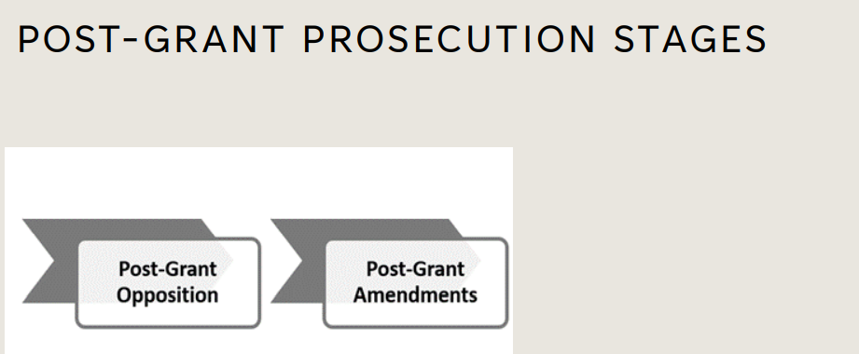

1. .**Post-Grant Opposition** • In India, under Section 25 (2) of the Patents Act, a post-grant opposition can be filed after the grant of a patent but within one year from the date of publication of the grant of a patent based on any of the grounds described under the said section
2. **Post-Grant Amendments Section 57 and Section 59** of the Patents Act provides the provision of both pre-grant and post-grant amendments. Section 59 states that the proposed amendments must meet certain requirements

Post-Grant Amendments Section 57 and Section 59 of the Patents Act provides the provision of both pre-grant and post-grant amendments. Section 59 states that the proposed amendments must meet the following requirements

**IPR**

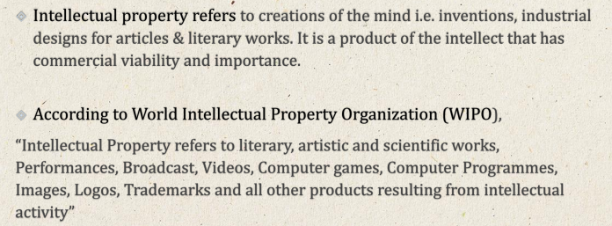

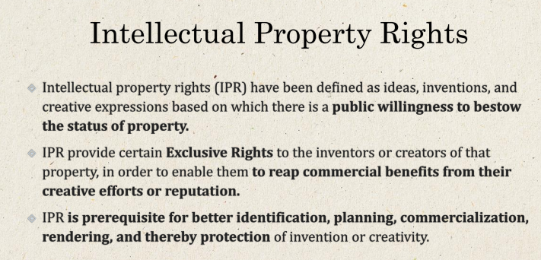

**SIGNIFICANCE OF IPR**

* **ECONOMIC PROGRESS**
* **ENHANCE RESEARCH ON TECHNOLOGIES**
* **PROMOT INOVATION**
* **FACILATE LICENCING**
* **ENCOURAGE INVESTMENST THUS INDUSTRIALIZATION**
* **AVOID DUP**
* **REDUCE COST OF PRODUCT**

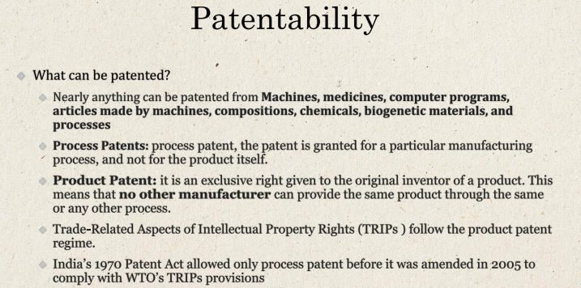

1. **UTILITY: is anything given below**

* **PROCESS any process you use to make shit**
* **COMPOSITION OF MATTER any thing you made to make shit**
* **MANUFACTURES shit the needs to go through manufacturing**
* **MACHINE machine for whatever your needs are**

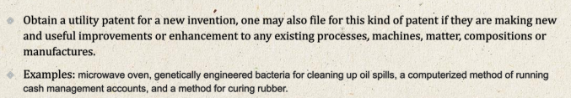

1. **DESIGN**

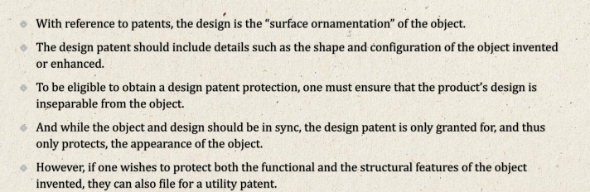

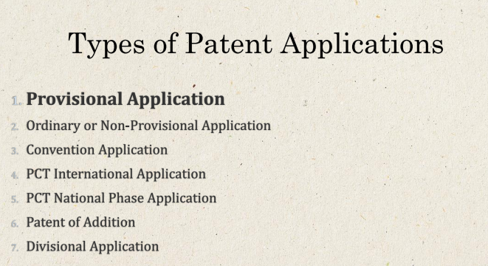

***I’ve written points to remember in the same order as the title above***

1. TEMPORARY’ FIRST TO FILE, CLAMING PRORITY, 12 MONTH VALIDITY, NEEDS TO IN CLUDE BREIF EXPLANATION ABOUT THE INVENTION
2. ORDINARY-DIRECT FILING- NO CORRESPONDING PROVISIONAL SPECIFICATIONS

SUBSECUENT FILING- COMPLETE SPECIFICATION CLAMING PRIORITY

1. CAN CLAM PRIORITY IN ALL CONVENTION COUNTRIES, FRIST FILE FROM IPO ONE YEAR PRIOR
2. GOVERNRD BY PATENT CORPORATION TREATY, IN 142 CONTRIES, 30-31 MONTHS TO ENTERR VARIOUS COUNTRIES

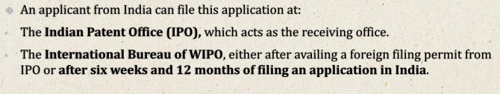

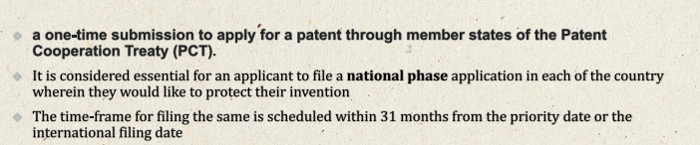

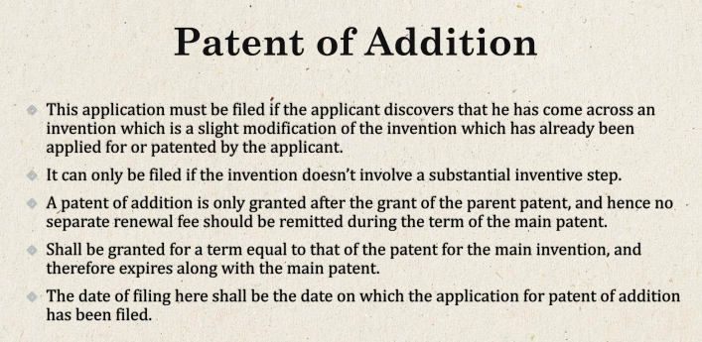

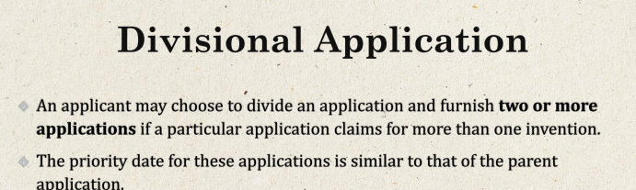

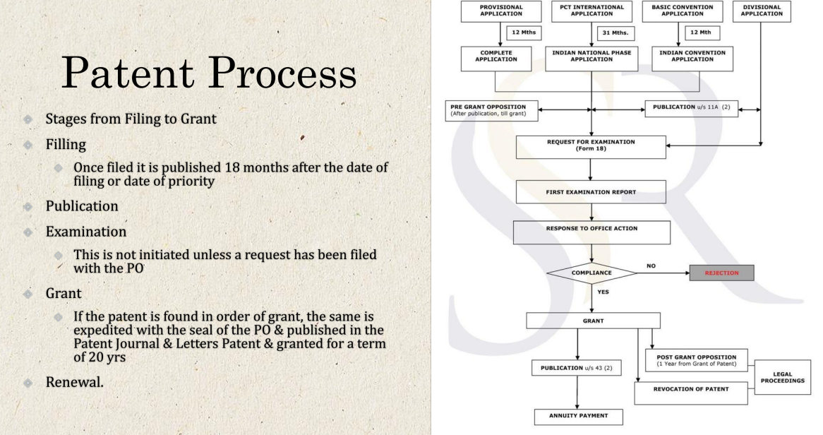

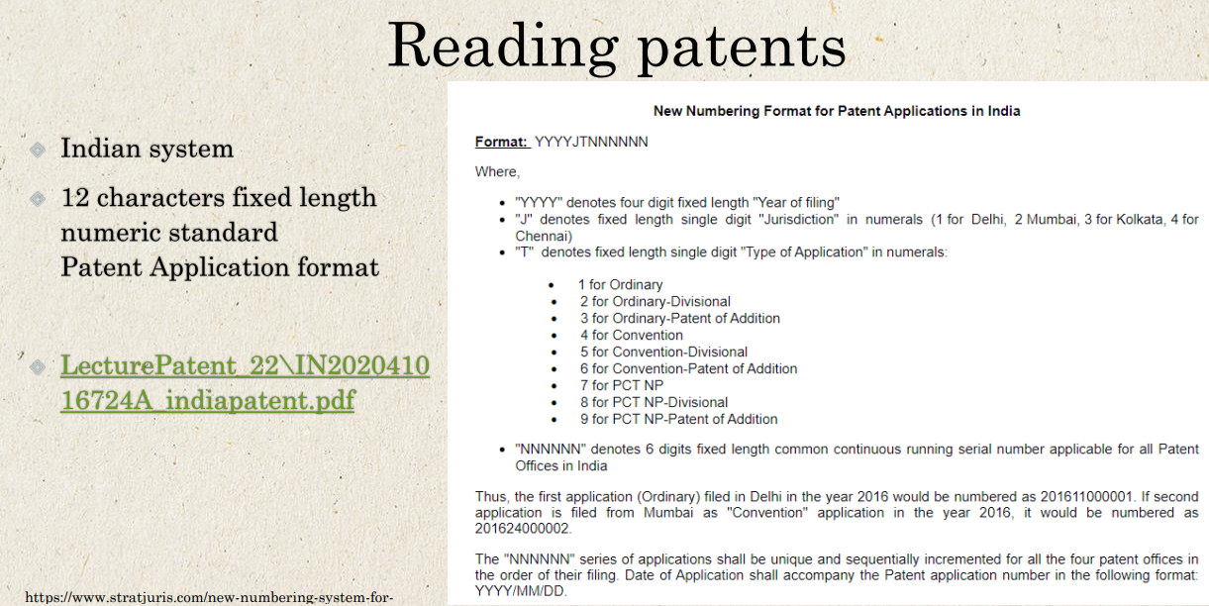

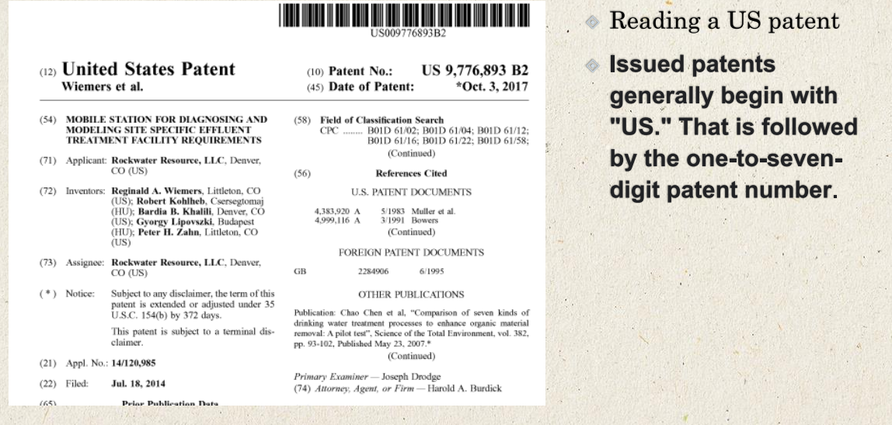

DBs for patents







**COPYRIGHTS**

**Copyright is a type of intellectual property that gives an originator the exclusive and assignable legal right, for a fixed number of years, to print, publish, perform, film, or record literary, artistic, or musical material**

* **Copyright laws allow products of creative human activities, such as literary and artistic production, to be preferentially exploited and thus incentivized.**
* **Copyright has developed into a concept that has a significant effect on nearly every modern industry, including not just literary work, but also forms of creative work such as sound recordings, films, photographs, software, and architecture**
* **1. In case of literary, dramatic or musical work:** 
  + **a) Reproducing the work in any material form which includes storing of it in any medium by electronic means,**
  + **b) Issuing copies of the work to the public which are not already in circulation,**
  + **c) Performing the work in public or communicating it to the public,**
  + **d) Making any cinematograph film or sound recording in the respect of work,**
  + **e) Making any translation or adaptation of the work.**
* **2. In case of a computer programme:** 
  + **a) To do any of the acts specified in respect of a literary, dramatic or musical works,**
  + **b) To sell or give on commercial rental or offer for sale or for commercial rental any copy of the computer programme.**
  + **Example: A programmer automatically owns the copyright of any program they write (it does not need to be applied for) and it lasts until 70 years after the death of the author.**
* **3. In the case of artistic works:** 
  + **a) To reproduce the work in any material from including storing of it in any medium by electronic or other means, depiction in three dimensions of a two dimensional work and depiction in two dimensions of a three dimensional work,**
  + **b) Communicating the work to the public,**
  + **c) Issuing copies of work to the public which are not already in existence,**
  + **d) Including work in any cinematograph films,**
  + **e) Making adaptation of the work, and to do any of the above acts in relation to an adaptation of the work.**

**Adaption in each category shall be explained\***

* **4. In the case of cinematograph film:** 
  + **a) To make a copy of the film, including photograph of any image forming part thereof or storing of it in any medium by electronic means or otherwise.**
  + **b) To sell or give on commercial rental or offer for sale or for such rental, any copy of the film,**

**c) To communicate the film to the public**

* **5. In the case of sound recording:** 
  + **a) To make any other sound recording embodying it “including storing of it in any medium by electronic or other means,**
  + **b) To sell or give on commercial rental or offer for sale or for such rental, any copy of the sound recording,**
  + **c) To communicate the sound recording to the public.**

**TERM**

**protection for the life time of the author plus 60 years beyond i.e. 60 years after his death.**

**In case of joint ownership, its till the last one’s dead**

**The act has given broadcasting reproduction right to every broadcaster which is valid for 25 years from the beginning of the calendar year**

* **Licenses by Owners of Copyright:**
  + **Section 30 of the act empowers the owner of the copyright in any existing work or the prospective owner of the copyright in any future work to grant any interest in the right by license in writing by him or by his duly authorized agent.**
  + **However, in the case of a license relating to copyright in any future work, the license shall take effect only when the work comes into existence.**

**Explanation.— Where a person to whom a licence relating to copyright in any future work is granted under this section dies before the work comes into existence, his legal representatives shall, in the absence of any provision to the contrary in the licence, be entitled to the benefit of the licence.**

